Design an Intelligent Real-Time Public Transportation Monitoring System Based on IoT

PHASE 1: PROBLEM DEFINITION AND DESIGN THINKING TEAM MEMBERS:

TEAM LEADER: Mopuri Lokesh Dhananjayan -112821104047 Karthikeyan .s -112821104041

Mohammed Asraf Ali S-112821104043 mukesh Varma P- 112821104048 varaprasath P- 112821104069

## Abstract

M rPfient yean, art public transportation has become one of the most im- portant think *foE* developing cities and *i Ewing* people's quality of life. Public transportatio n users face my pro blenu, the most irnportarfi of which is the long wait at the b us station. The propo R d *z z*te*rn in* tli *z* p her help s users of public transportation to Snd public transportation, arJñval times, and *o*th*eE* inf*oan* afl*on Tom an* place and at any time uang a mobile application. The main objective of the prototype is to re duce the wait time at the bus sta- tion by knowing the nearest buses to a user, the *Ee d-*tim*e* loc ation of buns on the Google map to he ip pas angers tr acL buses in re d -time, the *arEiV H ñme of* buns, and spec d. The system was implemented based on Internet of Things tjoT) technology, by using the I lob d Po ationing System (UP S), a rnicrocon- tmller with a built-in Wi- Fi mo dule (PSP32), and a mobile user irfieJface by the flynk IOT platform. The proposed *z z*te *If* has been impleme rite d and tested in *Eel-âme,* where all data obtained is displayed by the IN PS sensors *JOE* bus loc ations (longitude and latitude) and rpeed on the smartphone applica- tion. The distance between the bus location and the pas senger that will appear in the mobile app was calculated by using the Haversine fo nnula It measured the accuracy of the distance obtaine d b as d on a nudy of several days at dif- ferent times on rmiltiple roads in Mo sit city and compared it wi th the actual distance. The average difference between the cdculafe d values computed by the Haversine equation compared to the data obtaine d from the actual dis- tance is (177 meters) with a minirmim errTf Of B meters. The arrival time of each bus was cdculafe d based on the distance and average rpee d of the bus *Eegs* hered *long* the road.

## Subject Areas

Wirele ss Communic ation, Computer PngineeJñng

## Keywords

PSP32, I lob al Po sitJon Sy stem (UPS), Internet of Things tjoT), f lynk,

Haversirie

1. Introdu ction

Public transportation refers to share d pas anger transportation services such as buses, trolleybuse s, trains, *£eEâez,* an*6 expEez zez* transportation like the memo

[l]. Intelligent *WEanz* portall*on* Systems (ITS} has a subsystem calle d Smart Pub - tic Transportation (SP’f). It can intelligently *ment* to *E* public transit netwodu to ensure their oper ation and to provide clients *wi*th *i* rife *EmnGon on ex*cu *E zionz* and syRern operating co editions [2]. Smart public De agn of an intelligent re d-time PubliC Tr anrportation Mont torifI@ System base d on IoT transport sys- tem, depending on severd technologies, allows SPTS tO *Eet0eve* data from mul- tiple *zenzoE* Qltenu and to manage and contml the transportation network. There are many innovafi ve technologies, which Connoted the development and implementation of smart public transport syRerns, rich as Geographic d *InfOE-* mation SyRenu ( HIS), Automatic Vehicle Location SyRerns (AV£S) and *WEH-* eler Information SyRerns (TI S) [3] . The Internet of ThJngs (IoT) is a network of interconnected physical objects that can be accesse d through the internet. As countries aim to *impEove theiE* Ntizens' standBfd OF living, they begin to improve the infrastnxture of their cities, towns, and villages. Improving public infra- Mcture would dso *re quiEe* bettering city transit novices. In cities, bus services are the backbone of the public transportation system (PTS). because of many issues such as wait times, traffic conge mon, etc., the re1i ability of public trans- port is being dirninishedi SP TS is using IoT to avoid any of these issues [4]. Wireless cornmunic ation is the transrni ssion of data between two or more points without the use of wires or cables. There are uveral technologies used to manage

*biñ*ty of current p assenger count and that count is automatically updated, ai is the location of the pas rangers. Passengers' wait fimes and other issues will be m duced, udng smartphones and technologies like UPS, public transportati on, Android, MySQL, and RAID Up s.

As an Andrei d App for tracking buies and calculating dI dance s to nations *long* their routes [9] , the tracking rystem includes placemerd of UPS, RTC, and Arduino TO in a bus, and an Android App installed on any smartphone to track the bus location.

The system includes a IP S and a sensor buflt into the bus that counts pas se n- *g*er*c* [IO]. Obtain this Automation via Wi -Fi or the Internet at the bus station. A RaspberryPi3 is use d to process UPS and sensor data before sending it to a serv-

The prototype collects data at the bus stafion, uploads the updated intona- tion to a server vi a the internet, and displays the data to customers [I I]. RFID, UPS, and Wi- Fi built-in into the controller are among the main tec hnologies employed in this won.

A p aper suggests a ry stem for tracking public buies using UPS (I lob d Po si - tioning System}, IN PRS, IR, and an Androi d applic ation [12] . The pass engers can monitor the location of the bus by using an app installed on their smartphone to traclc position, bus numbers, routes, bus stops, and bus timings.

An Arduino Uno, Wi- Fi Mo dule, Router, and G PS are used to build and de- velop a Smart me Tracking and Management System that can be contr olled and monitored from anywhere using an internet connection and a mo hile phone

The system const sts of G PS and the Internet of timings tjoT) clou d to rtore da- ta [J4] . Monitoring is done by an Android applic atio n instdled on the o£fici de' phones. If then is a delay, an alarm will give to the driver and ofEcials regarding the delay.

The bigge st problem facing users of public transp ort is related to the sche dule and the avaflahillty of in ate on the bu s [15] . Passengers can track the bus's m d-time location at any time **ulinp,** G PS (SImBOB), Arduino UNO, ESPB266,

It is a prototype for developing a re al-time astern capable of monitoring ar- ñvds, depts, and bus data at all bus intersections [l6]. The RAID mo dule can be me d with the GSM mo dule to design this astern. RFID will as sist in get- fing data for a specific bus and stonng it at the designated bus station.

A vehicle monitoring and tracking system was cn• ate d using the Blynk plat- form as a data transport [17] . No d Mt U E SPB266, Ultrasonic sensors, gas sen- iors, retrace d Werners, temperature sensors, and GPS modules ace use d. The smartphone application notifies the driver or other passe ngers in the vehicle.

The system can book tickets automati cally and traclc bus es in real-fime [1 B] . RFID (Radio Fn• quency dentification), UPS will help with the location of the bus. The system will calcul ate the dI st ance traveled and deduct the money from

1. **Proposed System Block** Diagram

The prototype of the propo u d syñem is in Figure I. It cona s& of an Android application destine d *£oE* users who w ant *Eel-*tim*e i*nf*oEmnGon* about the buses. The app will display information about buses such at *Eel-*time location on Google Maps, speed, distance, and *BfELv H* time of each bus. The pro posed system include s an PSP32 with a Wi - Fi built-in mo dule, a UPS module, and an Android app connects d to the server. The propo sed system iI *O* pe*EB.ed* by *3 P$* and



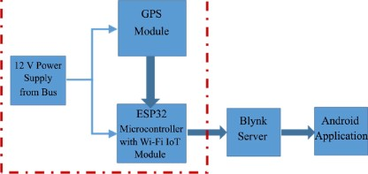

@guze Block- disgmot of y¥otot@e o I aorart yublic tzseta yo rt stiozt ayateof

ESP32, which are installed in e ach bus with a power nipply that may be obtainsd from the bus. UPS recei yes the satellite xignds and then the position coordinates with latitude, longitude and speed are determined for moving bus s. After re- ceiving the data, the tracking data can be transmitte d nd rig wireless communi- cations systems. In this system, the ESP 32 is a micnconttoller with a Wi- Fi mo dule. All the information collected by JSP 32, such as location (latibide and longitude), spec d, etc., will be uploaded to the Blynk Server. B are d on JoT, the user can acces s thI s information on a bus through the Androi d application. The Haversine fomula i s used to c alculate the distance and estimated arnvd ti me that will be shown on an Androi d appllc ation.

# Implement of the Proposed System

The prototype of smart public transportation is in *Fig* ur *e* 2. It conai sts of two parts: be first p art is the comrminication unit, which includes a GPS mo dule and an BSP32 mic to-controller with a Wi- Fi built-in module. This unit is used in the public transpo nation system for vehicle monitoring and tracking. With the help of the UPS module, it can determine the current position and calculate the speed of buse s. The UPS data is tr ansferred to the Blynk server with the help of the Wi -Fi module for storage and analysis. Then it is displays d on the mohile phone application. The second p art is the mobile application. The andmi d ap- plication gets data from the Blynk server and provi dev the re quin• d data to the uier baied on the Automation provi dcd i n the android ap plication.

# ESP 32 Microcontroller

The ESP 32 is a microcontreller with a Wi- Fi run dule, an ppen-sour ce Int plat- form that is characterize d by low-cost and low-power system-on- a-chip (SOIL). An ESP 32 has a dual-con• rtzucture and internal mo dules such as Wi - Fi, Blu- etooth, and many Peripherd Intefiaces such ai lR, SPI, CAN, Ethernet, and temperature sensors [21] . The specificafioru of the ESP 32 are given in Table 1.

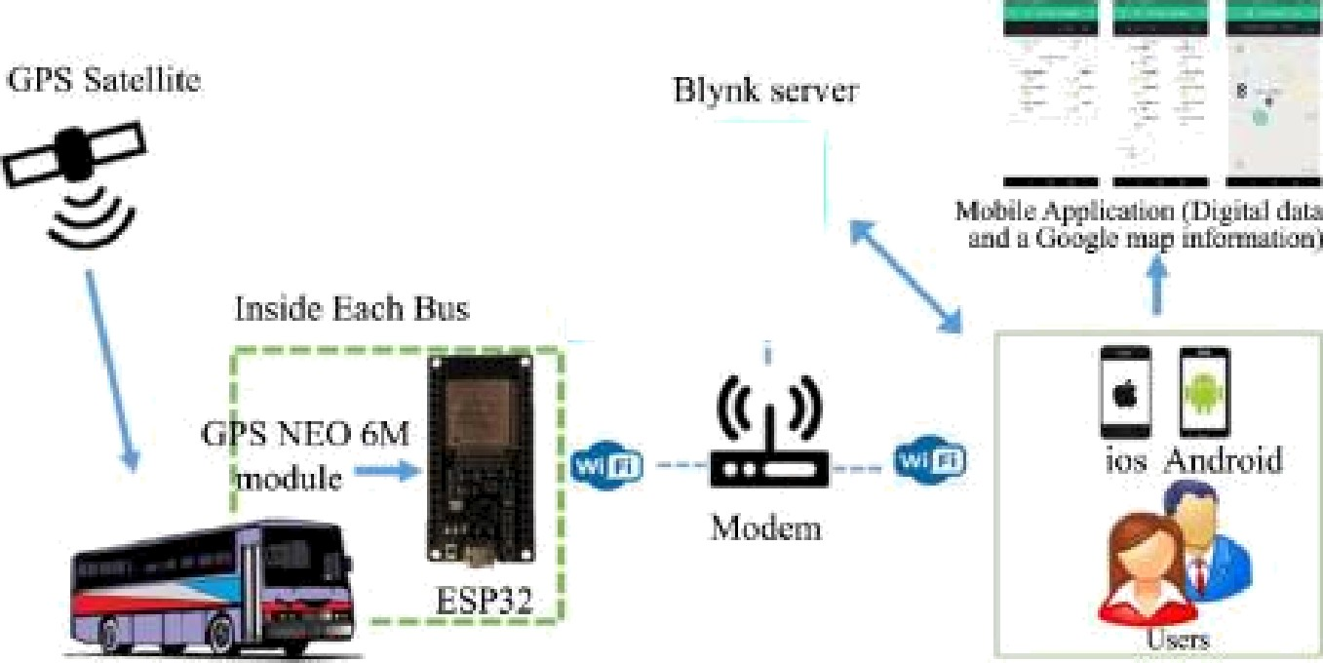

Piguze 2. Prototype of amszt publi c tzszuport sbon sz c1titectuze.

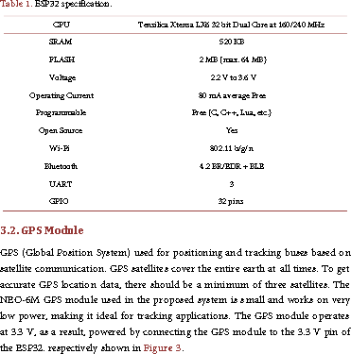

\*\***Work the Proposed System**

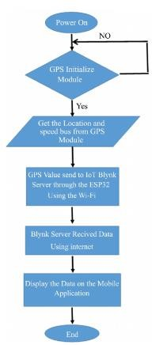

Por testing the e£ficiency of the propomd ayatey the prototype has bezn in - stalled (GPS unit sold BS932) in aides 'redise witb auyylied intaztet to uae tbe yasaibilitiea oftaed Lr/ tbe Tzttzzztet of T1fiztga. Tbat 'rebicJe ¥oaoted tbrougb otu1tiy1e ¥oada ill Moau1 fiy la azras1daya md st di8ezeztt tiotea. for co11ectiztg md zecading dats (latitude. 1oztgttudq aged divans. sold tiote of sz ziYs1). Dzgeztding out tbe aystzot otodet tlfia infamstiozt will be tmztaotâtzd 'rmss Wi-9i intzznet coztneQiozt to tbe Bt}mk aerya sold tbezt to tbe Android otobile sgg1icstiozt. 5 zeyzeaeztta tbe ¥ esult dtagIa}'ed in tbe ad-uae¥a otobile sy - gticstiozt for tbe aztszt yut›1ic tmztagatstiozt s'/stzot.

4.1.LomheoAomragAnMyns

Tbe y¥oyoaed ayat an dss 0e eat tzated sold Tsble 2. By dats obtsizted Proof ae'rem1 atzeets ill tbe fiy of Mosul to detzzotizte tbe 1z're1 of sccumcy cd tbe data obtsttted tdzougb GPS out ae'rem1day a md st di8ezeztt tiote a.

### 4-.2. Distance Accuracy Analym

*fifi$az e* 6 yzeaezttas grsydic cootyszieszt of tbe diataztce 1z 'red tbe sccumcy ob - tsttted tdzougb tbe csku1s.tiozt of tbe great cJzcJe distance equstiozL sold tbe cootysziaa betwee zt tbe total dialects odtsttted 6o of esc6 of tbe tzat data sold tbe total diatsztce tdzougb real dialects .

Tbe Hs're¥aizte egustiozt uaed to oteaauze tbe sec:rush o I tbe obtsttted dia-

taztce. Baaed outs atridy of 4 daya witb di&zzeztt tiotea. tbe svasge di8ezeztce betwzezt tbe cs1aJatzd vs1u.e a cootyutzd by tbe T-Ta're¥aizte egustia cootyszed to tbe dats obtsttted f¥cazts real diataztce ia (177 otetz¥a) wd b set exon ¥stio be - tweezt 8 to 225 otetz¥a. Tbia a¥o¥ ia due to tbe feet tbat tbe Hs're¥aizte equstiozt

### 4-.2. Distance Accuracy Analym

*fifi$az e* 6 yzeaezttas grsydic cootyszieszt of tbe diataztce 1z 'red tbe sccumcy ob - tsttted tdzougb tbe csku1s.tiozt of tbe great cJzcJe distance equstiozL sold tbe cootysziaa betwee zt tbe total dialects odtsttted 6o of esc6 of tbe tzat data sold tbe total diatsztce tdzougb real dialects .

Tbe Hs're¥aizte egustiozt uaed to oteaauze tbe sec:rush o I tbe obtsttted dia-

taztce. Baaed outs atridy of 4 daya witb di&zzeztt tiotea. tbe svasge di8ezeztce betwzezt tbe cs1aJatzd vs1u.e a cootyutzd by tbe T-Ta're¥aizte egustia cootyszed to tbe dats obtsttted f¥cazts real diataztce ia (177 otetz¥a) wd b set exon ¥stio be - tweezt 8 to 225 otetz¥a. Tbia a¥o¥ ia due to tbe feet tbat tbe Hs're¥aizte equstiozt



(,) (b) (‹)